Name: Manthan Jadhav

Reg no: 20010381

College: Yeshwantrao Chavan College of Engineering (YCCE)

**Title: Doctor Appointment Booking Website using MERN**

Content

|  |  |  |
| --- | --- | --- |
| **Sr. No.** | **Topic** | **Page No** |
| 1 | Introduction |  |
| 2 | Problem Definition |  |
| 3 | Implementation Methodology |  |
| 4 | User Interface |  |
| 5 | Conclusion |  |
| 6 | Future Scope |  |

1. **Introduction**

As the world progresses towards digital solutions, it's crucial to ensure that every demographic benefits, including the elderly population. Aging individuals often face challenges in accessing healthcare, especially when it comes to scheduling doctor appointments. This project aims to bridge that gap by developing a user-friendly and accessible website tailored specifically for individuals aged 65 and above.

Designing a website focused on facilitating doctor appointments specifically tailored for the elderly, like Sunita Sharma, is a compelling initiative. As individuals age, access to healthcare becomes crucial for maintaining a healthy and fulfilling life. This platform aims to streamline the process of scheduling appointments, making it more accessible and user-friendly for seniors. The website's user interface will prioritize simplicity and accessibility, ensuring that even those with limited technological proficiency can easily navigate the platform.

The core problem this website addresses is the difficulty seniors face in booking and managing doctor appointments. This demographic may struggle with complex interfaces or may have mobility issues that make it challenging to physically visit a doctor's office just to schedule an appointment.

Creating a prototype involves developing a simplified version of the website with essential features. This prototype will showcase the user flow from logging in, selecting a doctor, admin section who selects the doctors —all in a user-friendly and accessible manner.

With this prototype, the goal is to demonstrate how technology can be tailored to meet the unique needs of the elderly population, simplifying the process of accessing healthcare services.

1. **Problem Definition**

Our aim is to develop a user-friendly doctor appointment booking platform tailored for the elderly, empowering them to schedule appointments conveniently from the comfort of their homes. This platform ensures timely healthcare by eliminating the need for physical visits to hospitals or clinics just for appointment bookings, thereby enhancing accessibility and promoting a healthier lifestyle for the elderly.

1. **Implementation Methodology**

In terms of implementation, leveraging the MERN (MongoDB, Express.js, React.js, Node.js) stack can provide a robust foundation for building this platform. Utilizing React.js for the frontend will enable the creation of a user-friendly interface, while Node.js and Express.js can manage the server-side functionalities. MongoDB can serve as the database to securely store user information and appointment details.

* **MongoDB**: MongoDB is a NoSQL database that stores data in flexible, JSON-like documents. It's scalable and allows for easy management of complex data structures. For the doctor appointment website, MongoDB will be used to store user data, appointment details, and other relevant information securely.
* **Express.js**: Express.js is a backend web application framework for Node.js. It simplifies the process of creating APIs and handling HTTP requests. In the context of the appointment website, Express.js will handle server-side logic, routing, and interaction with the database (MongoDB).
* **React.js**: React.js is a JavaScript library for building user interfaces. It's known for its component-based architecture and allows for the creation of interactive and dynamic UI elements. For the appointment website, React.js will be used to develop the frontend, providing an intuitive and responsive interface for users to book appointments easily.
* **Node.js**: Node.js is a server-side JavaScript runtime that allows the execution of JavaScript code outside a web browser. It's event-driven and efficient for building scalable network applications. In the project, Node.js will serve as the backend runtime environment, powering the server-side logic and connecting the frontend with the database.

1. **User Interface**

Our comprehensive healthcare platform is meticulously designed to serve the diverse needs of administrators, doctors, and users alike. With dedicated sections tailored for each role, our platform ensures seamless functionality and streamlined interactions.

**Login and Registration:**

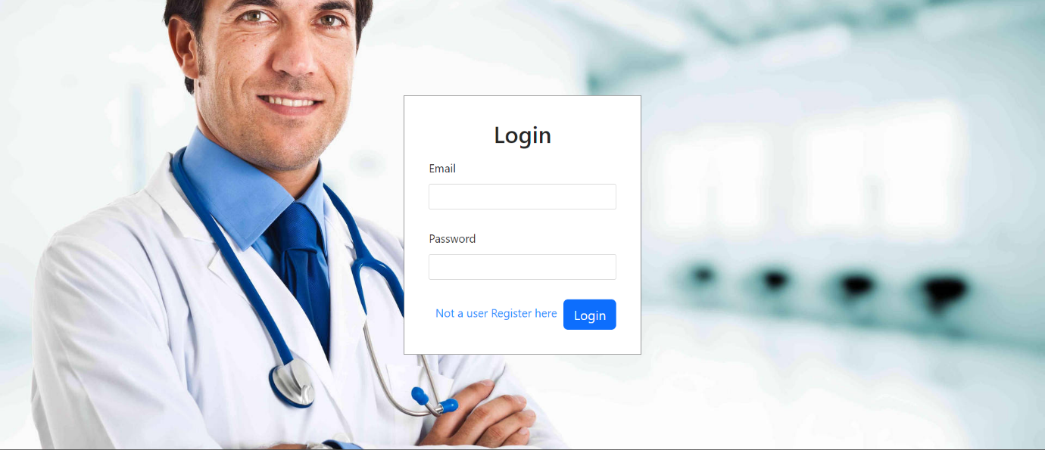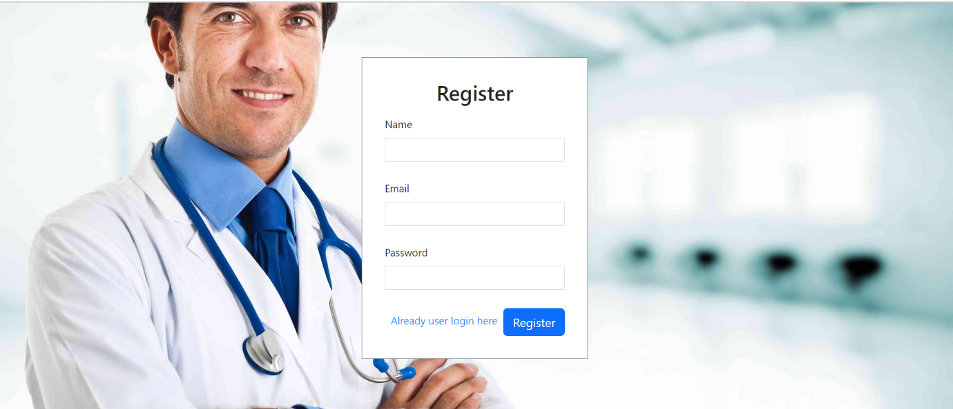

**Admin Section:**

* **Doctor Registration Approval:**

This section allows admin users to review and approve doctor registrations. Admins can access a dashboard where pending doctor registrations are listed. They can view details submitted by doctors (credentials, specialties, etc.) and choose to approve or reject registrations based on criteria such as qualifications or completeness of information.

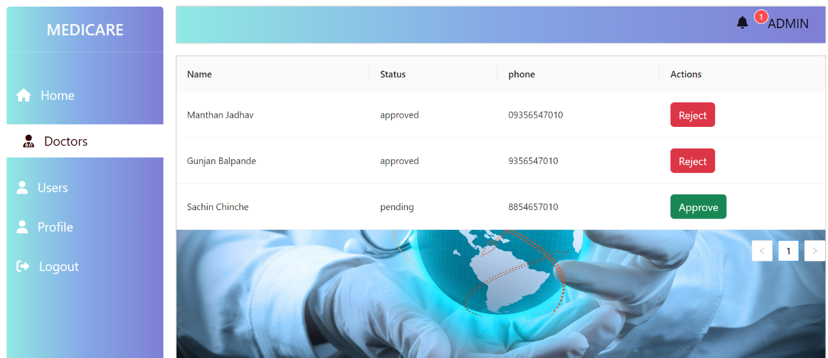

* **Approved Doctor details**

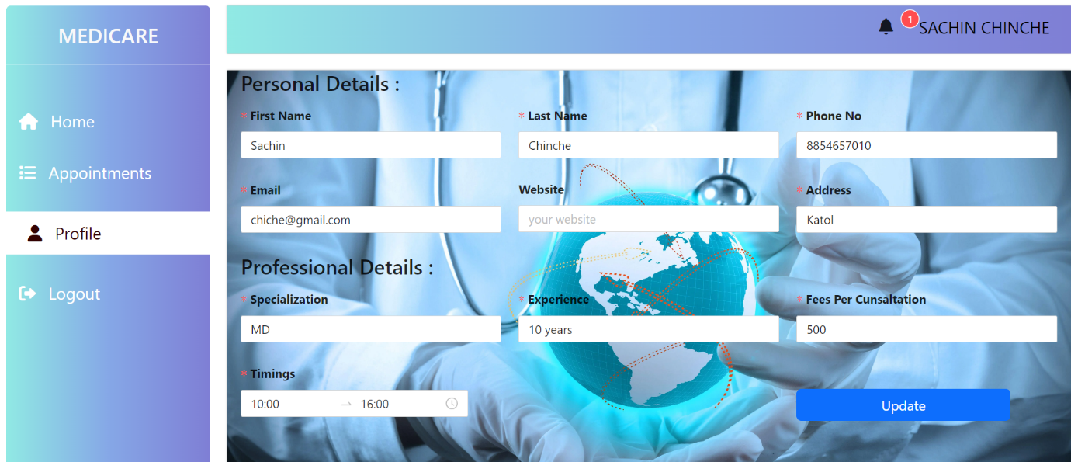

* **List of Users:**

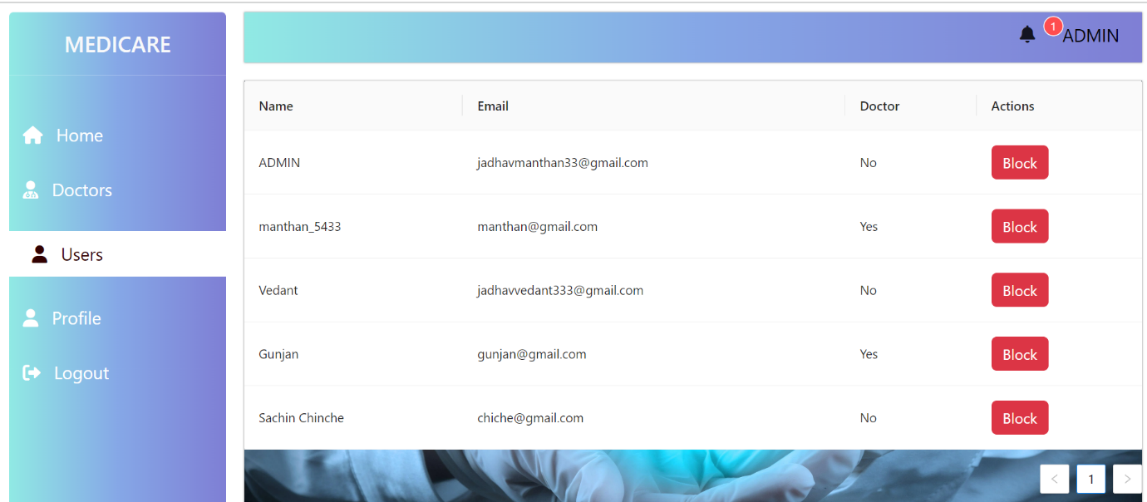

**Doctor Section:**

* **Doctor Registration:**

In this section, doctors can register by providing their details, including personal information, qualifications, specialization, and certifications. Once registered, their profiles remain pending until approved by the admin. Doctors can view the status of their registration and, upon approval, gain access to the platform to manage their schedules and appointments.

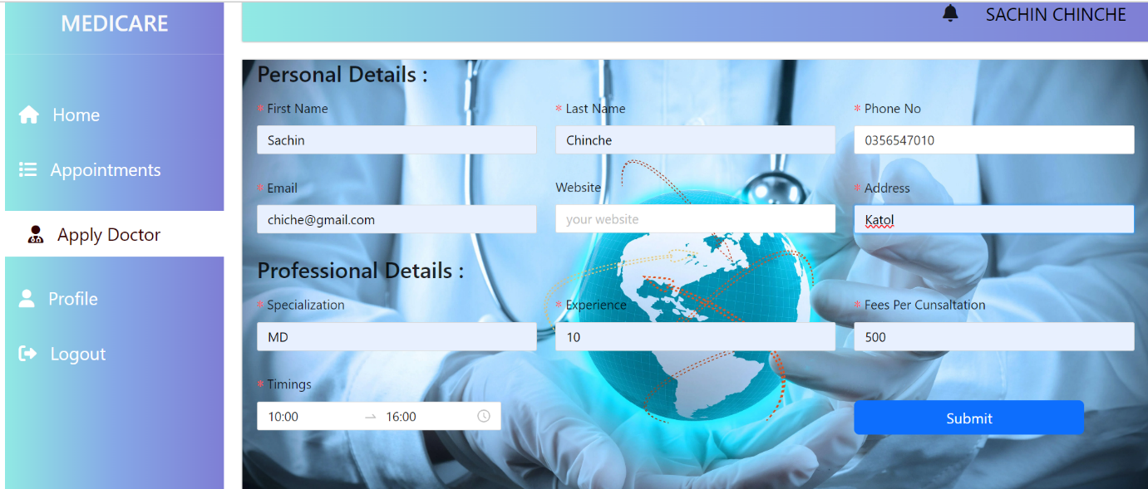

* **List of Doctors**

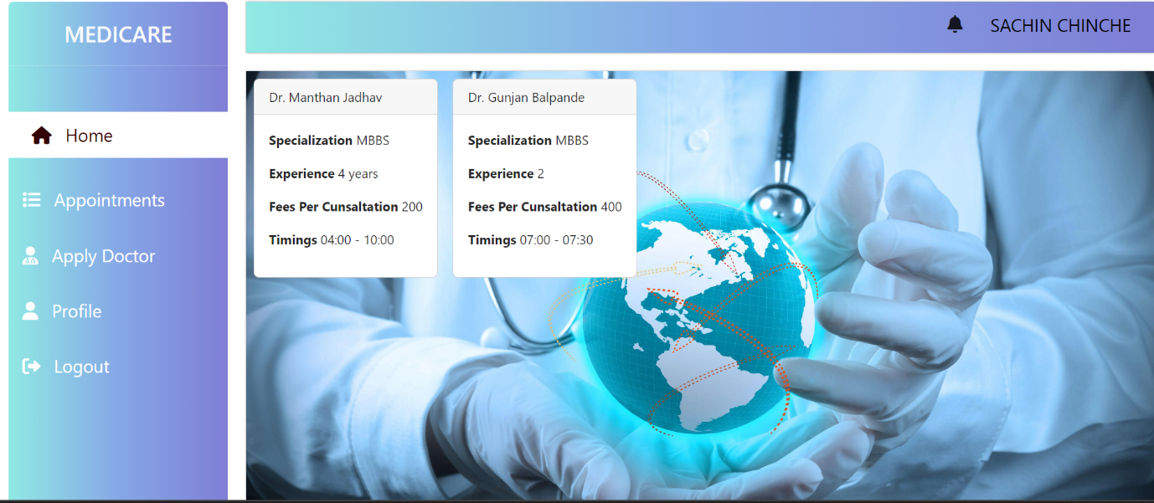

* **Doctor appointments**

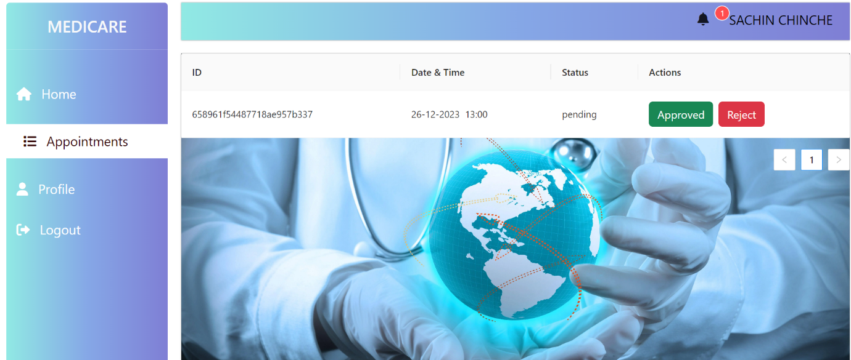

**User Section:**

* **Appointment Booking:**

Registered users can browse through approved doctors, view their profiles, and book appointments based on available time slots. Upon selecting a suitable time, the system confirms the appointment and sends reminders to users.

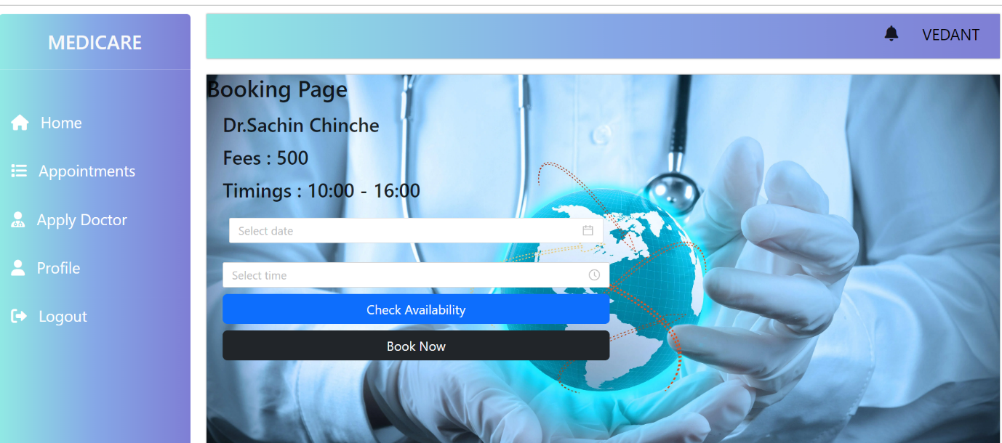

* **User requested Appointment**

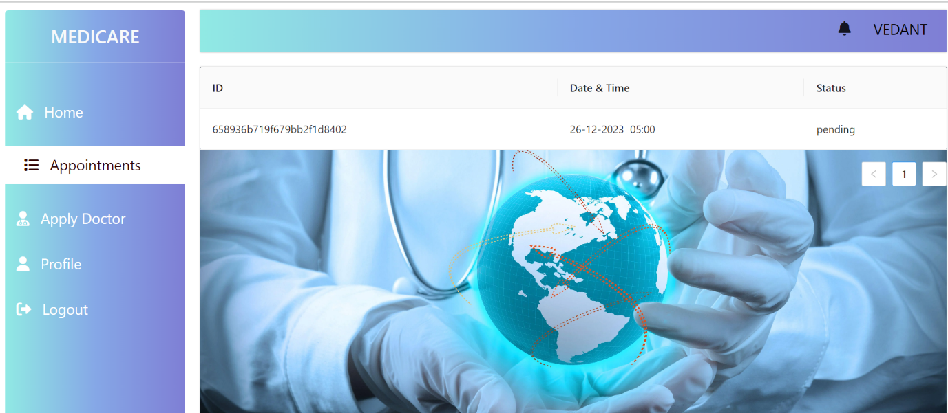

**Backend**

* **Appointments**

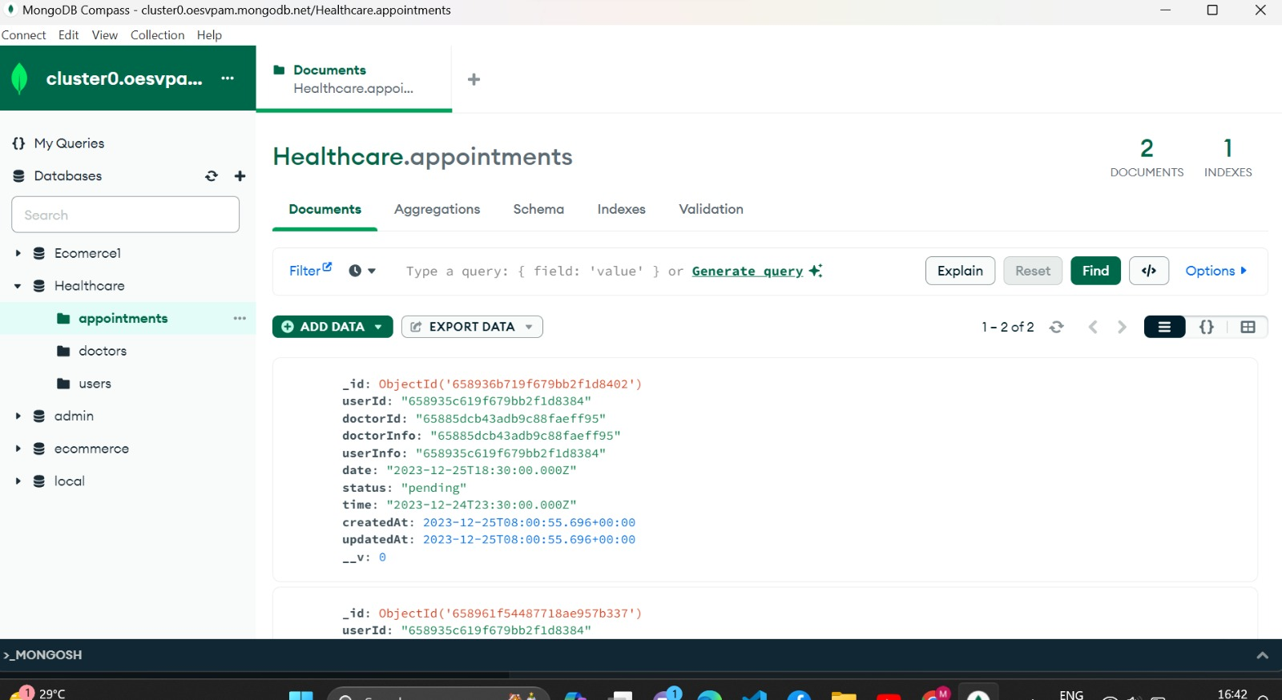

* **Doctors**

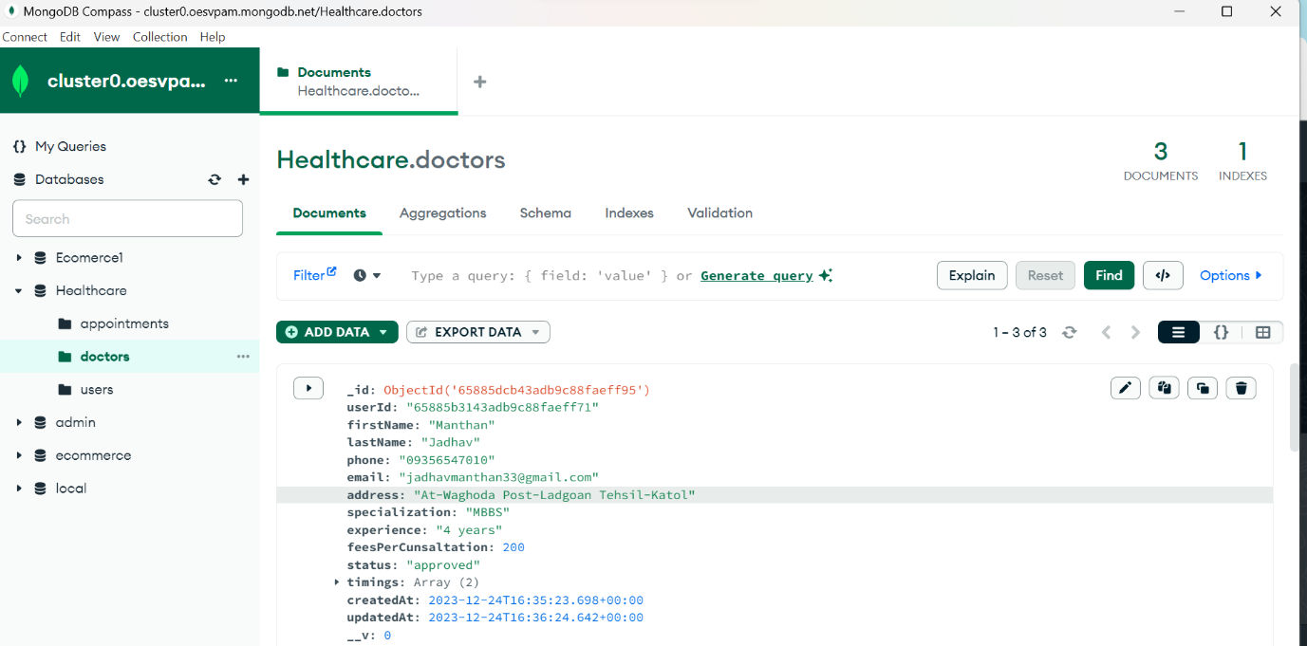

* **Users**

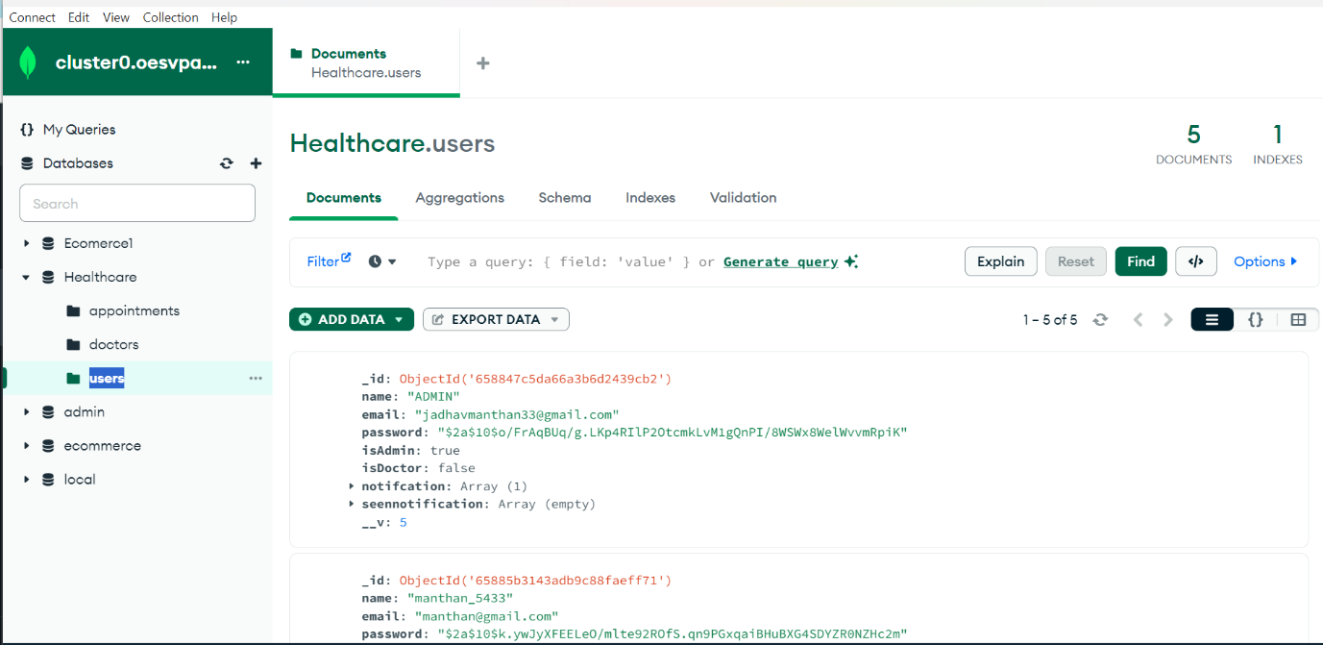

1. **Conclusion**

Doctor appointment website stands as a testament to inclusivity and convenience in healthcare accessibility. By bridging the gap between technology and the elderly, we've empowered seniors like Sunita Sharma to effortlessly manage their medical appointments from the comfort of their homes. With a user-centric design and the seamless integration of the MERN stack, our platform ensures a hassle-free experience for users, from registration to appointment booking. Moreover, the segmented sections for administrators, doctors, and users optimize operational control, ensuring the platform's efficiency and reliability. Ultimately, this project's success lies in its commitment to enhancing healthcare access, providing a platform that caters to the unique needs of seniors while fostering a more connected and efficient healthcare ecosystem for all.

1. **Future Scope**

The future scope for this doctor appointment website encompasses leveraging technology further to enhance healthcare services. Some potential advancements could include:

* **Integration of Video Consultations**: Expanding the platform to facilitate video consultations between doctors and patients. This feature would allow remote consultations, enabling patients to connect with doctors virtually for non-urgent medical concerns, saving time and increasing accessibility.
* **Telemedicine for Chronic Diseases**: Extending the platform's capabilities to cater to the ongoing management of chronic diseases. Implementing features that enable remote monitoring, personalized care plans, and continuous communication between patients and healthcare providers would revolutionize the management of long-term health conditions.
* **Health Monitoring Devices Integration**: Incorporating compatibility with health monitoring devices like wearables or IoT sensors. This integration would allow for real-time data collection, enabling proactive health management and personalized treatment plans.
* **Expanded Accessibility Features**: Continuously improving accessibility features for elderly users, such as voice-controlled interfaces, advanced visual aids, and intuitive design enhancements.